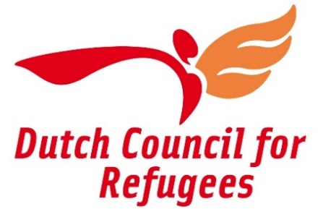

Application Form

STEP UP Capacity Fund 2023-2024

Small-scale support for NGOs in Cyprus, Greece, Italy, Malta, Poland and Spain, to step up capacity for refugee protection and inclusion

Application deadline: October 9th 2023

Please read the information and eligibility criteria set out in the application guidelines Step Up Fund 2023-2024

Name of the organization
Country
E-mail address contact person
E-mail address organization

You can fill in this form and upload it to your online form via this link by the 9th of October 2023.

Context in your country
A.1 Situation of refugees and asylum seekers in your country (max. 1000 words)
Briefly describe the policy-context and situation on the ground for asylum seekers and refugees in your country or region. What are the biggest challenges and/or opportunities for the protection and inclusion of refugees in your country?

A.2 Civil society in your country (max. 300 words)
Briefly describe the operating context for civil society and NGOs in your country. How NGOs are able to work on engage issues related to refugees and migration, what are the biggest challenges for NGOs?

Organizational background

B.1 Your organization
How would you describe your organization in simple words as you would to a friend?

B.2 Profile of your organization (max. 300 words)
Describe your organization’s profile with some details (e.g. what is your mission/ target group(s)/ areas of work/ / number of staff and/or volunteers/ and annual budget)

B.3 Experience working with asylum seekers and refugees (max. 300 words)
What is your experience in working for the protection and inclusion of asylum-seekers and refugees? Could you briefly describe the type of activities that you do for these groups (service delivery, legal aid, lobby and advocacy, community work, etc.)

Project proposal on capacity development

C.1 Project information

Project title
Project location (where (which city/region/country) will the project be implemented)

C.2 Challenges / capacity-need (max. 100 words)
What are the challenges (/capacity-need) of your organisation that this the project wants to address?

C.3 Project description (max. 1000 words)
What do you want to achieve with this project, and what activities do you propose?

C.4 Results and sustainability (max. 400 words)
What results do you expect from the project, and how will the results have a lasting/sustainable impact on the ability of you organization to better support and protect refugees and migrants?

C.5 Project planning/Timeline
What is your proposed timeline for your project activities? (Please note that the project should be implemented between December 2023 and November 2024)

C.6 Budget
Please provide a budget proposal.
An example of a template you can use is provided below. You can also submit your own budget proposal separately [in excel or another format]. Please note that only proposals with a maximum budget of 10.000 EUR will be eligible for support.

 | Budget item | Amount (in local currency) | Amount (in EUR) | Justification (explain the budget item and amount)
A | Human Resources
A.1 | Staff cost
A.2 | Consultancy costs
A.3 | …..
B | Meetings (workshops, study visits, trainings, etc)
B.1 | Venue
B.2 | Equipment
B.3 | Meals
B.4 | Accommodation
B.5 | Transportation
B.6 | …
C | Publications and materials
C.1 | Printing advocacy report/tools
C.2 | Translation
C.3 | …
D. | Other costs
D.1 | ….
Total budget

Capacity development support by the Dutch Council for Refugees
(This question is optional, you do not have to fill it out!)
Is there any specific topic on which you would like to learn more from the Dutch Council for Refugees? (Please refer to section 3 of the call for proposals for more information) ²

Any other information

You can provide any other information that you think is relevant to know about your organisation or the project here

We understand capacity development to be an investment in the effectiveness and future sustainability of an NGO, and will consider projects that are aimed at organizational, knowledge and strategic development, development of new projects and programs and trying out new working methods
The selected NGOs will – if they like – be offered capacity-building support by Dutch Council for Refugees in the form of training or twinning. Together with the selected projects who are interested in receiving this support, we will work out a modest tailor-made capacity-building session/program, for example in areas such as advocacy, legal aid, working with volunteer or fundraising.

